1. Literacy in pre-school children: Article in English Language Teaching Professional regarding the task presented at the Plenary.

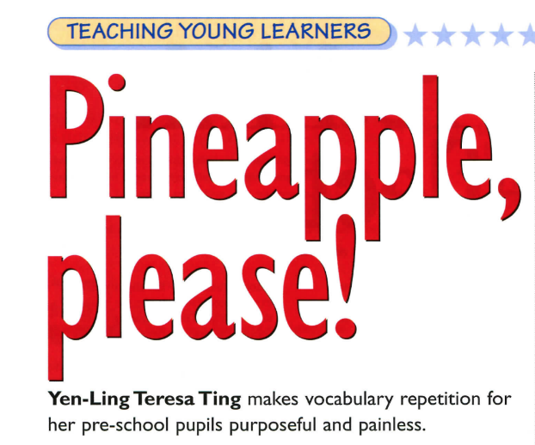 | 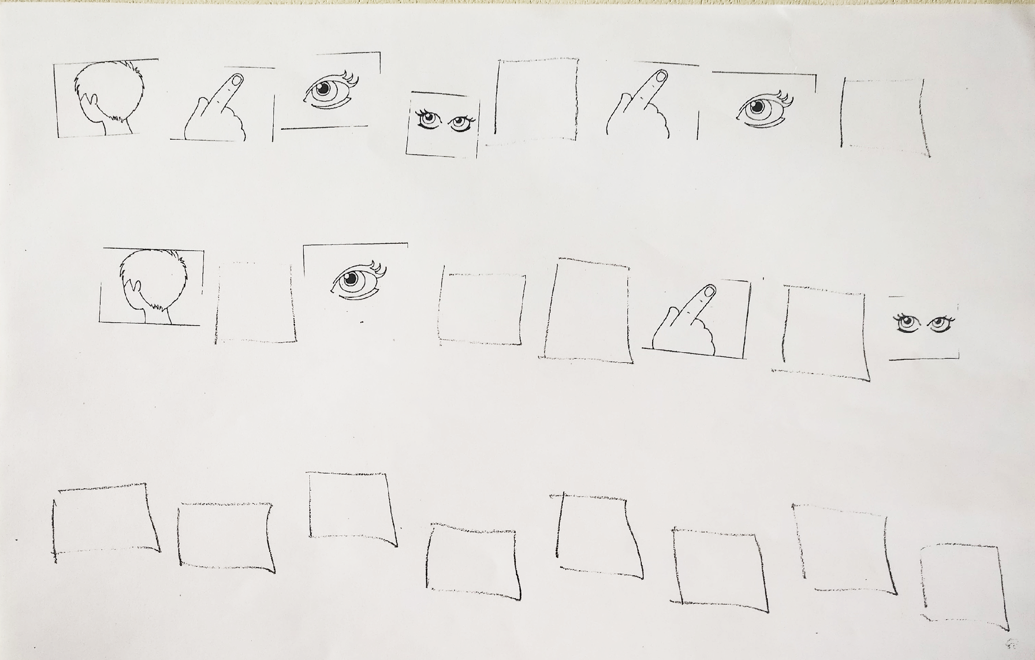

2. Age-appropriate disciplinary literacy in 8-year olds (History of the Earth: example of worksheets)

3. M&M Experiments from the American Chemical Society: These describe the experiments very nicely, with several different “optional modifications”.
However, note that there is little attention towards “productive literacy”, helping students then properly language what they have observed and accurately language about the explanation. Thus the importance of “completing the learning” by designing tasks that cultivate “productive disciplinary discourses and literacies”.

https://www.acs.org/content/acs/en/education/whatischemistry/adventures-in-chemistry/experiments/dissolving-m-ms.html

https://www.acs.org/content/acs/en/education/resources/k-8/inquiryinaction/fifth-grade/chapter-1-investigating-matter-at-the-particle-level/dissolving-an-m-and-m.html

4. Here are “CLIL-Pages” created for the 3-Level (B1, B1-Upper, B2-Lower) “Talent” series of EFL textbooks published by Cambridge University Press. I was asked to create, 10 CLIL-Pages for each Level with each 2-page spread covering one of five school subjects, Art, Geography, History, Maths, and Science, all tied through a common theme per Level. For example the common running theme for Level 1 was “insects and sustainability”; Level 2 “urbanization”; Level 3, “epidemics”.... Yes, the CLIL-Pages of Level 3, published in 2018, helped students understand the how and why of a pandemic.

Thanks to permission from Cambridge, I can share these CLIL-Pages: go to the site below (ISSUU) and follow the links to download the pages for your students.

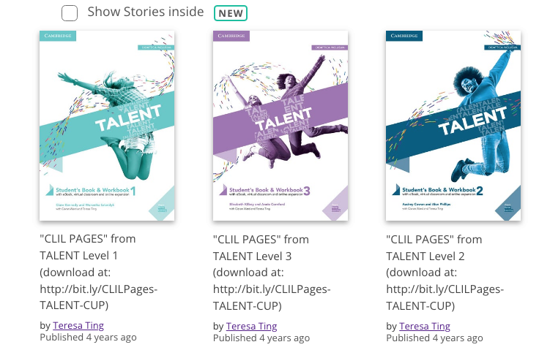

A few other articles/books that might be of general interest to language teachers.

1. Let’s all monologue: how to elicit language about complex content from ALL learners. 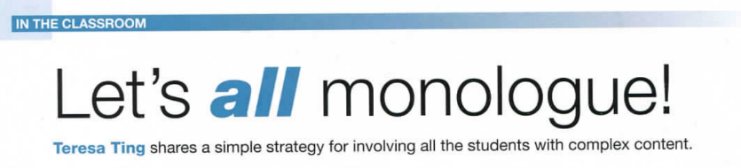

2. Useful Reference Books for Teachers / Teacher-Training
“FARE CLIL” (In Italian):
- Part 1: Why do CLIL (MIUR decision makers);
- Part 2: How to do CLIL (How the brain works (Learning); Content, Language, Integration (examples of weak CLIL materials)
- Part 3: Case studies from CLIL teachers who I have trained: assessment strategies.

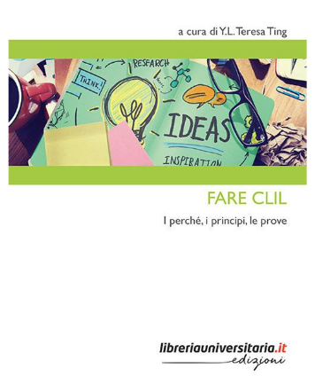

“CLIL ESSENTIALS” (in English):
Although “about CLIL”, Peeter has incorporated many very useful ideas for general teacher-training at secondary.
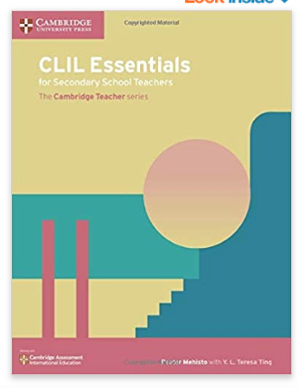

More academic research articles regarding CLIL:
