
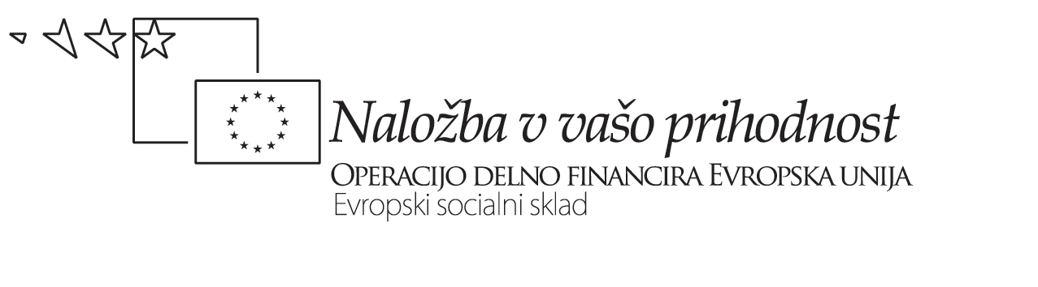


Datum: 15/10 – 2009 | Projekt USPOSABLJANJE UČITELJEV ZA UVAJANJE  POSODOBITEV GIMNAZIJSKIH PROGRAMOV

Besede, besede, besede …: REFLEKSIJA

Razmislite o tem, kako razumete pojma MEDPREDMETNA POVEZAVA in KURIKULARNA POVEZAVA. Sta za vas tako sopomenska, da je eden odveč , ali pa je med njima pomembna pomenska razlika, ki utemeljuje in upravičuje obstoj in rabo obeh? Denimo, da je menite slednje …

- Najprej ponazorite razliko med poimenovanjema s primeri iz vaše ali tuje prakse.
1.1 Primer(i) medpredmetne povezave:

_________________________________________________________________________________________________________________________________________________________________________________________________________________________________________________________________________________________________________________________________________________________________________________________________________________________________________________________________________________________________________________________________________________________________________________________________________________________________________________________________________________________________________________________________________________________________________________________________________________________________________________________
___________________________________________________________________________

1.2 Primer(i) kurikularne povezave:

____________________________________________________________________________________________________________________________________________________________________________________________________________________________________________________________________________________________________________________________________________________________________________________________________________________________________________________________________________________________________________________________________________________________________________________________________________________________________________________________________________________________________________________________________________________________________________________________________________________________________________________________________________________________________________________________________
- Zdaj pa poskusite zapisati definiciji obeh pojmov. Morda si pri tem pomagate z Vennovim diagramom in najprej ugotovite, kaj imajo medpredmetne in kurikularne povezave skupnega, kaj pa jih razlikuje.

Značilnosti

medpredmetnih povezav

Značilnosti

kurikularnih povezav

Značilnosti, skupne

medpredmetnim in kurikularnim povzavam

medpredmetnih povezav

  - Medpredmetna povezava je …

___________________________________________________________________________________________________________________________________________________________________________________________________________________________________________________________________________________________________________________________________________________________________________________________________________________________________________________________________________________________________________________________________________________________________________________________________________________________________________________________________________________________________

  - Kurikularna povezava je …

________________________________________________________________________________________________________________________________________________________________________________________________________________________________________________________________________________________________________________________________________________________________________________________________________________________________________________________________________________________________________________________________________________________________________________________________________________________

