DELOVNI LIST: URBANIZACIJA ZDA 2. ___/G Ime in priimek

1. Sestava ameriškega mesta. V prazne kvadratke vpiši osnovne dele ameriškega mesta.

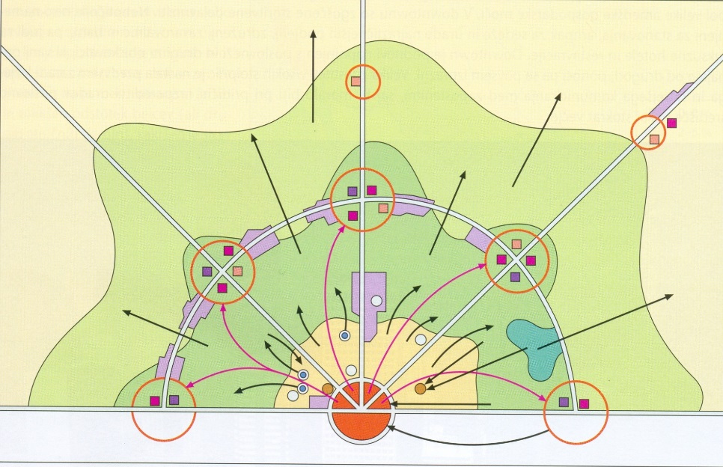

1. Razloži razliko med pojmoma GETO IN SLAM.

GETO _____________________________________________________________________

SLUM _____________________________________________________________________

1. Slika prikazuje slam v Detroitu. Ob sliki napiši glavne značilnosti slamov in kako problem rešujejo.

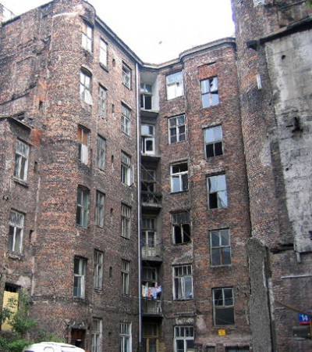Glavne značilnosti:

* __________________________________________
* __________________________________________
* ___________________________________________
* ___________________________________________

Reševanje problemov:

* __________________________________________
* ___________________________________________
* ___________________________________________

1. Kar 65 % mestnega prebivalstva živi v predmestju. Navedi tri vzroke za to:

* ________________________________________________________________________________________
* ________________________________________________________________________________________
* ________________________________________________________________________________________

Kdo se še seli s prebivalstvom v predmestja in zaradi katerih vzrokov?

* __________________________________________
* ___________________________________________
* ___________________________________________

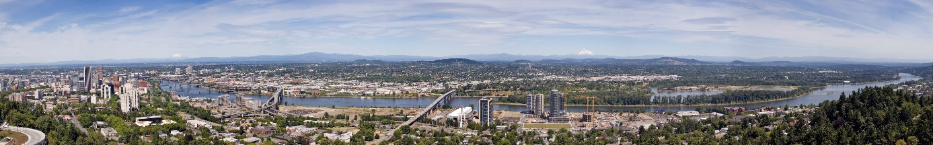

1. Is this a european city or an american city? __________________________________
2. How do you know?

____________________________________________________________________________

1. Which city do you think it is? ______________________________________________
2. Work with a partner:

Look at the map and decribe the city.

____________________________________________________________________________________________________________________________________________________________________________________________________________________________________________________________________________________________________________________________________________________________________________________________

List at least 4 things that are different from european cities.

* ______________________________________________________________________________________________
* ______________________________________________________________________________________________
* ______________________________________________________________________________________________
* ______________________________________________________________________________________________

Is there anything that is the same as in european cites?

* ______________________________________________________________________________________________
* ______________________________________________________________________________________________
* ______________________________________________________________________________________________
* ______________________________________________________________________________________________

Is anything surprising or strange about the city?

* ______________________________________________________________________________________________
* ______________________________________________________________________________________________
* ______________________________________________________________________________________________
* ______________________________________________________________________________________________