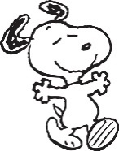 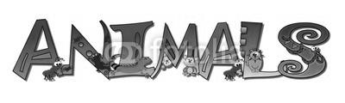   
“Until one has loved an animal a part of one's soul remains unawakened.” - Anatole France

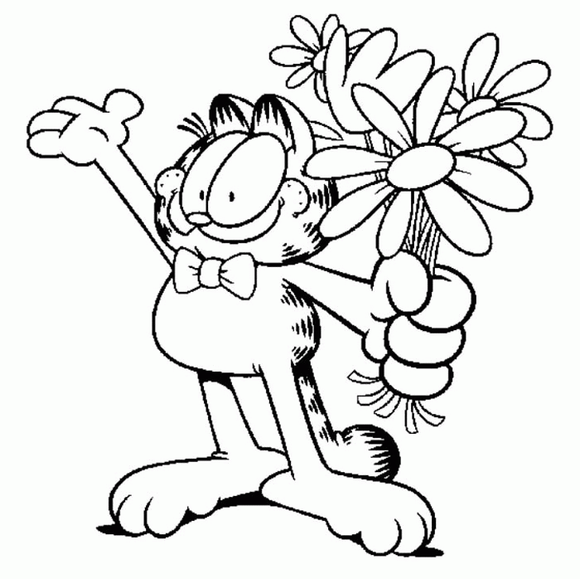**CLASSIFYING ANIMALS**How many groups of animals can you think of? Give a few examples for each one.

**ANIMAL SOUNDS**  
Match the animal with the verb used to describe the sound they make. Then write down the sound we hear (if it’s any different).

|  |  |  |
| --- | --- | --- |
| ANIMAL | VERB | SOUND |
| LION  HEN  HORSE  CAT  DOG  COW  BEE  PIG  ELEPHANT MOUSE  OWL  SHEEP  FROG  WOLF  SNAKE  DUCK ROOSTER  BIRD | buzz  bleat  croak squeak  roar  crow  sing hiss  moo  grunt  cluck  bark  howl  neigh  quack  meow  trumpet  screech |  |

**ANIMAL IDIOMS**Can you complete these expressions with the names of animals? Do you know what they mean?

1. To have ________ in one's pants.
2. The __________ 's got one's tongue.
3. To have a __________________. (Think Bart Simpson)
4. To kill two ___________ with one stone.
5. ______________ see, __________________ do.
6. It's raining _________________ and ___________________.
7. To __________ out at a meal.
8. To let the ________________ out of the bag.
9. To be in the ____________ house.
10. Hold your ___________________!
11. To get the ____________________'s share.
12. To be a copy __________________________.

**ANIMAL FAMILIES AND GROUPS**Fill in as many of the categories as you can!

|  |  |  |  |  |
| --- | --- | --- | --- | --- |
| ANIMAL | MALE | FEMALE | BABY | GROUP |
| Alligator |  |  |  |  |
| Bear |  |  |  |  |
| Bee |  |  |  |  |
| Bird |  |  |  |  |
| Cattle |  |  |  |  |
| Cat |  |  |  |  |
| Chicken |  |  |  |  |
| Crow |  |  |  |  |
| Deer |  |  |  |  |
| Dog |  |  |  |  |
| Duck |  |  |  |  |
| Elephant |  |  |  |  |
| Goat |  |  |  |  |
| Goose |  |  |  |  |
| Horse |  |  |  |  |
| Kangaroo |  |  |  |  |
| Lion |  |  |  |  |
| Moose |  |  |  |  |
| Pig |  |  |  |  |
| Sheep |  |  |  |  |
| Tiger |  |  |  |  |
| ANIMAL | MALE | FEMALE | BABY | GROUP |
| Alligator | bull | cow | hatchling | congregation |
|  |  |  |  |  |
| Bear | boar | sow | cub | / |
|  |  |  |  |  |
| Bee | drone | Queen / worker | larva | hive / swarm |
|  |  |  |  |  |
| Bird | male | female | chick | flock |
|  |  |  |  |  |
| Cattle | bull | cow | calf | herd |
|  |  |  |  |  |
| Cat | tomcat | queen | kitten | clutter / litter |
|  |  |  |  |  |
| Chicken | rooster | hen | chick | flock |
|  |  |  |  |  |
| Crow | cock | hen | chick | murder |
|  |  |  |  |  |
| Deer | stag | doe | fawn | herd |
|  |  |  |  |  |
| Dog | dog | bitch | pup | pack, litter |
|  |  |  |  |  |
| Duck | drake | duck | duckling | flock |
|  |  |  |  |  |
| Elephant | bull | cow | calf | herd |
|  |  |  |  |  |
| Goat | billy | nanny | kid | herd |
|  |  |  |  |  |
| Goose | gander | goose | gosling | gaggle |
|  |  |  |  |  |
| Horse | stallion | mare | foal: filly (f)  colt (m) | herd |
|  |  |  |  |  |
| Kangaroo | jack | jill | joey | troop / herd |
|  |  |  |  |  |
| Lion | lion | lioness | cub | pride |
|  |  |  |  |  |
| Moose | bull | cow | calf | herd |
|  |  |  |  |  |
| Pig | boar | sow | piglet | sounder |
|  |  |  |  |  |
| Sheep | buck | ewe | lamb | herd |
|  |  |  |  |  |
| Tiger | tiger | tigress | cub | ambush |