**A Canadian Quiz, Eh!**

[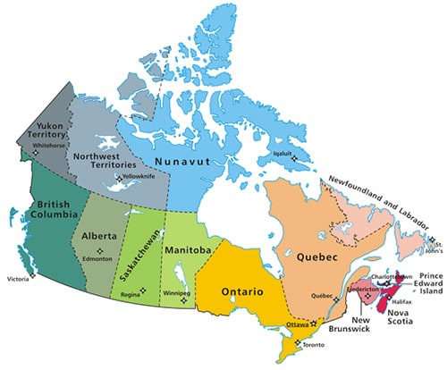](http://www.google.si/url?sa=i&rct=j&q=&esrc=s&frm=1&source=images&cd=&cad=rja&docid=_Ty5wmVSmSC5jM&tbnid=WUuBosOkMNUqmM:&ved=0CAUQjRw&url=http%3A%2F%2Fwww.globalnerdy.com%2Ftag%2Fwindows-server%2F&ei=h8M2UoaOC4LRtQa_-4DYBA&bvm=bv.52164340,d.bGE&psig=AFQjCNEWNfR_QBsCoaPGa7rQoLenxpBJ0w&ust=1379406983744056)

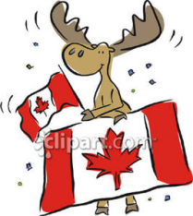Canada was originally settled by the First Nation people and the Inuit many thousands of years ago. Europeans arrived briefly in 1000 AD, but didn't return until 1497 when John Cabot explored the Atlantic Coast for Great Britain. The first permanent settlements were French. Led by Samuel de Champlain, the French established Port Royal and Quebec City in the early 1600s.  
  
After the Seven Years War most of Canada became part of the [British Empire](http://www.ducksters.com/geography/country.php?country=United%20Kingdom). Canada continued to expand and in 1867 was officially proclaimed the Canadian Confederation. There were four provinces in the Confederation including Quebec, Nova Scotia, New Brunswick, and Ontario. Britain, however, still maintained control over Canada's foreign affairs. It wasn't until 1982 with the signing of the Canada Act that Canada became a fully independent nation.  
  
Canada is a large geographic country that is rich in natural resources. Canadians hope to develop their natural resources and energy sources while still protecting the environment.

** Source for population (2012 est.) and GDP (2011 est.) is CIA World Factbook.

**Let's see what you know about Canada** ☺

|  |
| --- |
| 1. **What is Canada's national animal?** |

Moose

Beaver

Loon

Polar Bear

|  |
| --- |
| 1. **What is Canada's national winter sport?** |

bingo

lacrosse

ice hockey

curling

|  |
| --- |
| 1. **What food do Canadians consume per capita more than any other nationality on earth?** |

French fries

hamburgers

sushi

macaroni and cheese dinner

|  |
| --- |
| 1. **The Canadian Government has turned its small bills into coins commonly known as "loonies" and "toonies". True or False?** |

True

False

|  |
| --- |
| 1. **Canada has a small population, and a majority of the people live in igloos. True or false?** |

True

False

|  |
| --- |
| 1. **Canada's national police force is the Mounties.** |

True

False

|  |
| --- |
| 1. **What is the name of Canada's most famous sailing vessel?** |

the Bluenose

the Rednose

the Brownnose

the Greennose

|  |
| --- |
| 1. **What is the capital city of Canada?** |

Toronto

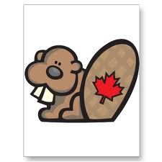Halifax

Vancouver

Ottawa

Sources: duckster.com & funtrivia.com