Pneumatics – part 2 (teacher version)

Task 1 PNEUMATIC CYLINDERS
Watch the video on pneumatic cylinders and decide whether these statements are true or false. Then correct the false statements. Link: https://www.youtube.com/watch?v=VgKFoC3K5UI

- Pneumatic cylinders are used to push things forward and backward. (T)
- The distance the shaft (piston) of a cylinder comes out is called its bore size. (F)
- Stroke refers to the capacity inside the cylinder body. (F)
- A bigger bore results in bigger force exerted by the cylinder. (T)
- As the bore size increases, the shaft decreases. (F)
- The most common type of cylinder is the double acting cylinder. (T)
- Double acting cylinders have two air ports, one to extend the cylinder and the other one to retract it. (T)
- The shaft in a single acting cylinder is originally in the extended position. (F)
- Both reverse acting and single acting cylinders have springs. (T)
- Universal mounting means that the cylinder can be mounted on both sides. (T)
- Nose mount cylinders can only be mounted from the top. (T)
- Stainless steel cylinders are cheaper than their aluminium counterparts. (F)

Task 2 PNEUMATIC SYMBOLS
Write down the English term for the following symbols.

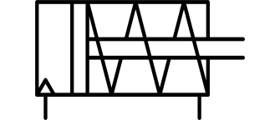 |  |  | 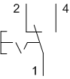
(1) SINGLE ACTING CYLINDER |  |  | (2) PUSH BUTTON
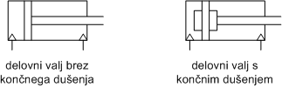 |  |  | 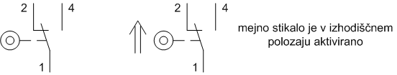
(3) DOUBLE ACTING CYLINDER |  |  | (4) LIMIT SWITCH
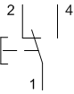 | 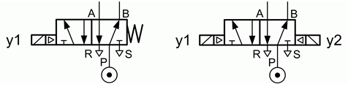
(5) SWITCH | (6) DIRECTIONAL VALVES  (monostable) (bistable)

Task 3 Match the key terms about pneumatics to their definitions. There is one term too many.

limit switch | relay | double acting cylinder | directional valve
power supply | compressed air | conveyor belt | switch
single acting cylinder | actuator | solenoid operated | manually operated
flow control valve | air supply system | piston | button

Definition | Key term
- air kept under a pressure that is greater than atmospheric pressure | compressed air
- controlled or processed by hand | manually operated
- a device for making and breaking the connection in an electric circuit | switch
- a small device on a piece of electrical or electronic equipment which is pressed to operate it | button
- the moving component that is contained by a pneumatic cylinder | piston
- a cylinder in which the compressed air acts alternately on both sides of the piston | double acting cylinder
- an electrically operated switch | relay
- a switch operated by the motion of a machine part or presence of an object | limit switch
- device that supplies electric power to a system | power supply
- a valve that allows compressed air to flow into different paths from one or more sources | directional valve
- a valve that regulates the flow or pressure of air into a pneumatic system | flow control valve
- an electrically driven compressor pumping air into the storage tank at high pressure | air supply system
- a type of motor for moving or controlling a mechanism or system | actuator
- controlled by an electric current through a solenoid | solenoid operated
- a cylinder in which the compressed air acts on one side of the piston only | single acting cylinder

