*Introduction to Pneumatics (student version)*

**Pneumatics**

Pneumatic systems use the energy stored in compressed air to do work. By controlling the release of air into the system, we can turn that energy into controlled movement.

*- Source: http://www.bbc.co.uk/schools/gcsebitesize/design/systemscontrol/pneumaticsrev1.shtml*

**Task 1 PARTS OF A PNEUMATIC SYSTEM**

**Write down the English terms for the pneumatic parts described below.**

|  |  |
| --- | --- |
|  | ***Parts*** |
| 1. a machine that extracts air from the atmosphere and compresses it into a holding chamber | kompresor |
| 1. the main storage area for compressed air | glavni rezervoar |
| 1. a device that regulates the air flow into the rest of the system | regulator |
| 1. a connecting part that is shaped like the letter T, used for creating a branch line or splitting a single line in two | T povezava |
| 1. a secondary storage area for extra compressed air which ensures that full power is delivered in short intervals | dodatni rezervoar |
| 1. a piece of piping that moves air around the system | dovajalna cev |
| 1. a device that can hold the pressure built up on one side and is able to 'pop' completely open so that a pocket of compressed air is rushed out | ventil |
| 1. a mechanical part which uses the power of compressed gas to produce a force resulting in a linear motion | cilinder/valj |
| 1. the device that generates electricity for the system | napajalni vir |
| 1. a device used to start or stop the system | stikalo |

**Task 2 SIMPLE PNEUMATICS IN ACTION**

1. Watch the video of a simple pneumatic system and then label the parts on the schema below.

|  |  |
| --- | --- |
| **Part** | **Name** |
| 1 |  |
| 2 |  |
| 3 |  |
| 4 |  |
| 5 |  |
| 6 |  |
| 7 |  |

*Link: https://www.youtube.com/watch?v=7O_9ucZoABY*

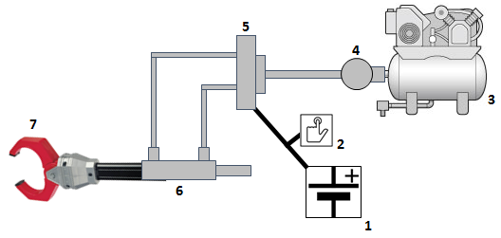

1. How much pressure was the regulator set to?
2. What is output voltage of the power supply?
3. How can you adjust the speed at which the claw opens and closes?
4. How do you set the default opening and closing speeds?

**Task 3 ADVANTAGES OF PNEUMATICS**

**Write down the advantages of pneumatics that are explained below. For each explanation, your answer should be in the form of a concluding statement.**

1. Pneumatic systems use compressed air. We know already that this is just the air we breathe, forced into small spaces. If a pneumatic system develops a leak, it will be air that escapes and not oil. This makes pneumatics suitable for food production lines.

***CONCLUSION:***

1. We cannot use electronics for applications like paint spraying because many electronic components produce sparks and this could cause the paint to catch fire.

***CONCLUSION:***

1. Many companies invest in pneumatics because they know they will not have a lot of breakdowns and that the equipment will last for a long time.

***CONCLUSION:***

1. Pneumatic components last for a long time, which means they do not need to be replaced too often. Moreover, pneumatics uses air, which is readily available for free around us.

***CONCLUSION:***

1. Once you have bought the basic components, you can set them up to carry out different tasks.

***CONCLUSION:***

1. Pneumatic systems do not need to be insulated or protected like electronic systems.

***CONCLUSION:***