**WILLIAM SHAKESPEARE**

William Shakespeare was a **1__________________ (poetry)** and a playwright, and is **2__________________ (wide)** regarded as the **3_________________ (great)** writer in the English language. He was **4_______________ (bear)** in Stratford-upon-Avon, in **5___________________ (center)** England, in 1564 and he died in 1616. His **6____________________ (survive)** work consists of 38 plays, 154 sonnets (a special type of poem with 14 lines), and some other poems. He is best **7______________ (know)** for his plays, which have been **8______________________ (translate)** into every major language and are performed more than those of any other playwright in the world.

When William Shakespeare was 18 years old he **9______________ (marry)** Anne Hathaway, and they had three **10_______________ (child).** Shakespeare went to London to work as an **11______________ (act)** and a writer. In 1599 the Globe Theatre was **12________________ (build)** in London and it was in this theatre, situated on the banks of the River Thames, that some of Shakespeare's plays were first performed. In 1613, the theatre was **13_________________ (destroy)** by a fire. However, a modern reconstruction of the theatre was built near the **14_______________________ (origin)** site in 1997 so even today you can go to the Globe Theatre to see one of Shakespeare's plays.

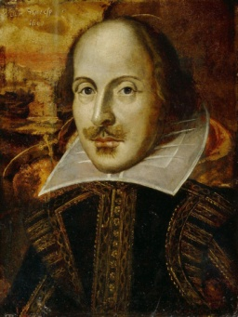

 Taken from: <https://www.teachingenglish.org.uk/language-assistant/essential-uk/shakespeare>

**SONNET 130**

My mistress' eyes are nothing like the sun;   
Coral is far more red than her lips' red;  
If snow be white, why then her breasts are dun;  
If hairs be wires, black wires grow on her head.  
I have seen roses damask'd, red and white,  
But no such roses see I in her cheeks;   
And in some perfumes is there more delight  
Than in the breath that from my mistress reeks.  
I love to hear her speak, yet well I know  
That music hath a far more pleasing sound;  
I grant I never saw a goddess go;  
My mistress, when she walks, treads on the ground:  
   And yet, by heaven, I think my love as rare  
   As any she belied with false compare.

|  |
| --- |
| **Glossary:**   **dun:** a dull greyish–brown color **hath:** has **damask’d:** separated by color **tread:** to walk **reek:** stink; a bad smell **belie:** to show something to be false or wrong |