Practicing Basic Skills in a Productive Way
Erich Ch. Wittmann, Technical University of Dortmund, Project “mathe 2000”

Worksheet 1: Hedgehog-triangles
Rule: In a hedgehog triangle the three numbers in the circles have to be added, the resulting hedgehog number is written in the middle of the triangle. The number 0 is not admitted.
Exercise 1: Fill in the missing numbers.
Exercise 2: Coupled hedgehog triangles
Write the numbers 1, 2, 3, 4 and 5 in the five circles such that the hedgehog numbers in both triangles are equal.
Note: The number in the middle circle has to be used twice.
There are several solutions. Try to find them.

Worksheet 2: A dynamic system

Rule: Choose a number within the domain 1 – 100. If it is even, then halve it, if it is odd, then add 9. Repeat this process until you get into a loop.

Examples: 44, 22, 11, 20, 10, 5, 14, 7, 16, 8, 4, 2, 1 (10, ….) (Loop 1)
51, 60, 30, 15, 24, 12, 6 (15, …) (Loop 2)

Start with other numbers and discover a third loop (Loop 3).

Any sequence will end in one of the three loops. Mark numbers which lead to loops 1, 2, 3 in the hundred chart in different ways (for example with different colors or different symbols).
Which patterns do you notice?
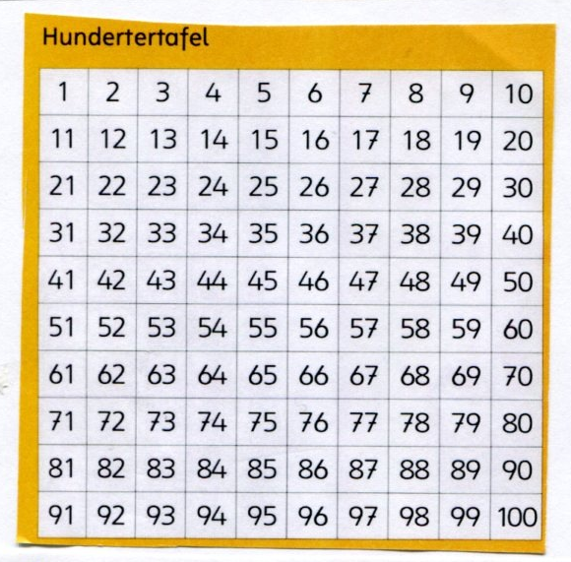

Worksheet 3: Always three tasks

Start with an arbitrary subtraction task of three-digit numbers.
Calculate the complement of the second number (the subtrahend) to 1000.
Add this complement to the first number (the minuend).

Example:

Subtract: 563 – 287 =

Calculate the complement: 287 + ____= 1000

Add: 563 + ____ =

Results of this example:

Subtract: 563 – 287 = 276

Calculate the complement : 287 + 713 = 1000

Add: 563 + 713 = _____

Calculate several examples.

What do you observe? Try to explain it.

Worksheet 4: Multiplication top-down and criss-cross

Exercise 1:
Choose two pairs of subsequent numbers and arrange them in a square.
Then perform two multiplications, one top-down and a second one criss-cross. Add the products in both cases and compare the results.

Examples:

Calculate several examples.
What do you notice? Try to explain it.

Exercise 2:
Choose now pairs of numbers which differ by 2 (or by 3, …) and execute the same calculations.

Examples:

Workshop at KUPM 2012, Maribor August 23 – 24, 2012
Wittmann, E.Ch. & Müller, G.N., Probieren und Kombinieren. Igelaufgaben zum Zahlenbuch 1 – 4. Stuttgart: Klett
Wittmann, E.Ch. & Müller, G.N. , Das Zahlenbuch. Vol. 3. Stuttgart: Klett
Wittmann, E.Ch. & Müller, G.N. , Das Zahlenbuch. Vol. 3 Stuttgart: Klett
Wittmann, E.Ch. & Müller, G.N. , Das Zahlenbuch. Vols. 2 – 4. Stuttgart: Klett

