Name: .......................................................... Class:.........

Calculating areas
by counting nails

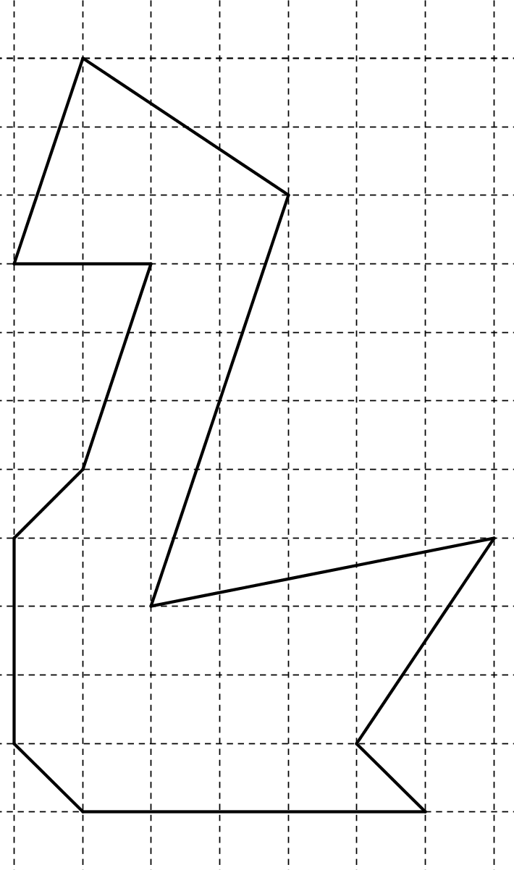
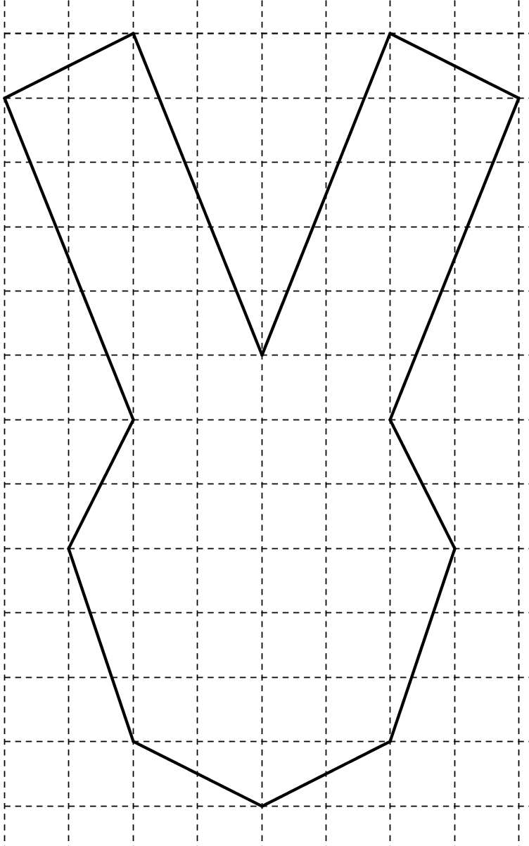

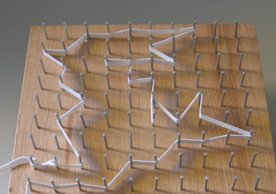
Everybody gets a nail board and an elastic band to work with. You may assume that the distance between two neighbour nails is exactly 1 cm, so you do not have to use your ruler. We are going to create figures on this nail board.

Assign two secretaries in your group. These two take a sheet titled “Table of conclusions”. Every figure build by one the group members, will come into this table. You will need this to discover relationships between the numbers you write down. So fill this table with great accuracy.

Next to the sheets with tables of conclusions, you will find working sheets. Here you can draw the figures you made. Enjoy your nail expedition!

(Step 1) Everyone makes a rectangle on his nail board. Take care that everyone in the group has a different rectangle. The picture gives an example of a rectangle with length 6 cm and height 5 cm. Make another one yourself.

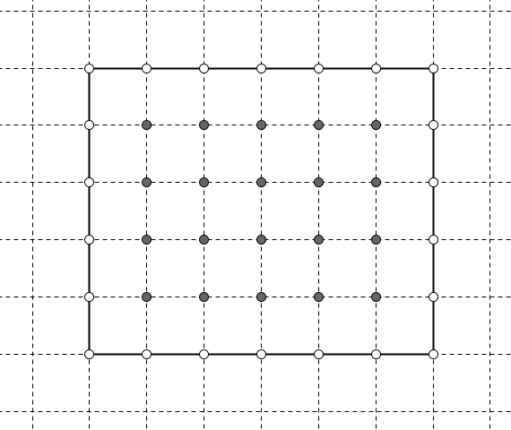
Count the number of nails that lie completely inside your rectangle, i.e. like the 20 grey dots on the picture: ……..
Count the number of nails that lie on the border of your rectangle, i.e. like the 22 white dots on the picture; ……...
Remember that the distance between nails was 1 cm, so every little square in the picture has an area of exactly 1 cm². Now write down the area of your rectangle: …….…….. (don’t forget the right unit).

Secretaries put all results of all rectangles on the sheet “Table of conclusions” (last column stays open for this moment). The example of the picture above, is already filled in with the correct numbers.
(Step 2) Now we examine triangles. Divide the group into two subgroups. In one subgroup everyone makes a rectangular triangle on his nail board (take one horizontal and one vertical side).

In the second subgroup everyone makes a non-rectangular triangle with one horizontal side. Again make sure every one has a different triangle.

First, look at the following example. In the picture below you see a rectangular triangle with sides 6 cm and 5 cm. The area of this triangle is ………… Explain how you came to this conclusion.

…………………………………………………………………………………………..

…………………………………………………………………………………………..
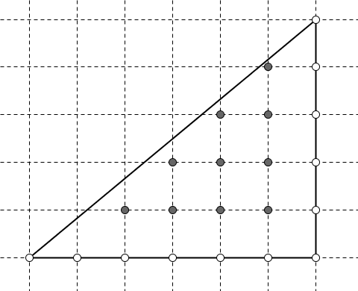
Count the number of nails that lie completely inside this triangle (grey): ……..
Count the number of nails that lie on the border of this triangle (white): ……...

Now return to your own triangle and count again the nails.
If you hesitate whether a nail lies completely inside or just on the border of the figure, use a working sheet to draw the figure in detail.
How many nails lie inside your figure: ...........
How many mails lie on the border of your figure: ......................

What is the area of your triangle? (Give a short explanation how you can see this).

…………………………………………………………………………………………..

Secretaries put all results of all rectangles on the sheet “Table of conclusions”. The fast workers can find a more challenging triangle in step 3.

When everybody of the group is ready with step 2, the whole group can proceed with step 4.
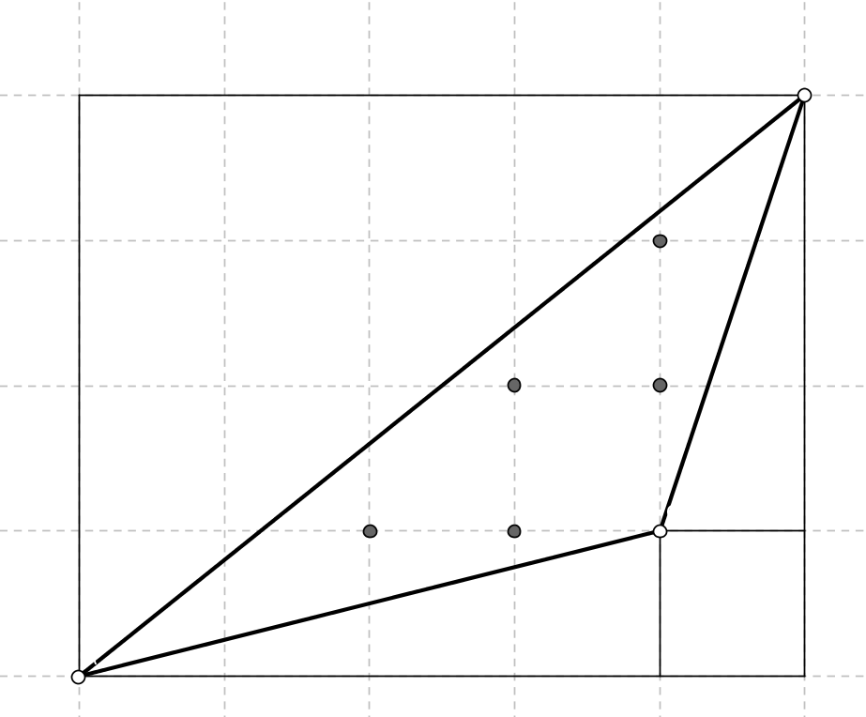
(Step 3) Look at the triangle in the picture aside. Counting the number of nails should be doable. The more difficult part is to calculate the area of this arbitrary triangle.

This can be done by the following reasoning: the area of this triangle is the area of the great rectangle minus the very small rectangle and the three rectangular triangles (look at the thin black lines in the picture).
Calculate the area on the back of this paper and write down the conclusion.
(Step 4) We do a little calculation with the number of nails and complete the right column of the sheet “Table of conclusions”.

In the second column, the secretaries wrote down the number of nails that lie completely inside the figure. This nails are counted completely.

In the third column of the sheet, the secretaries wrote down for each figure the number of nails that lie on the border. Remark that a nail on the border, can be considered to be half inside, half outside the figure. For this reason, we only count this nails as ‘half a nail’.

This gives us the way to calculate a number. This calculated number will be put in the right column “calculations step 4”. Let’s take the example rectangle in step 1. This figure had 20 nails inside and 22 nails on the border. So the calculated number will be: 20 (of the nails inside) + 11 (half of the nails of the border) equals 31. This is the calculated number for the right column.

Divide the group into two subgroups. Every subgroup completes the right column of the sheet “Table of conclusions” for every figure. The two subgroups then compare their results.

(Step 5) We look for a relationship between the area of the figures and the calculated numbers in step 4. So look closely to the two columns on the right of the sheet “Table of conclusions”. What relationship can you detect? Put this as precise as possible in words below:

..........................................................................................................................................

This seems to work for every figure you can build on a nail board. We therefore conclude that it is possible for these figures to calculate areas just by counting nails. Complete the conclusions in the box:

Conclusion (discovered by G.A. Pick in 1899):
On a nail board where nails are lying ...... cm from each other, the area (in cm²) of a polygon made by an elastic band equals:
the number of nails ………………………………………
PLUS HALF the number of nails ………………………………………………………….,
MINUS .........

(Step 6) This formula can be used to calculate areas of all kinds of figures, including more difficult ones. Calculate the area of the following figures, using the formula above. You can also try to make figure a-b on your nail board.
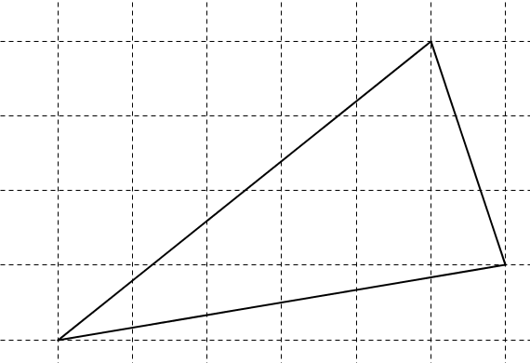
a)
Number of nails inside figure: ....

Number of nails on the border: ....

Area: ..............

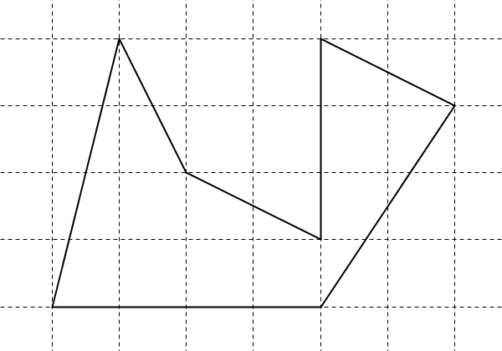
b) Number of nails inside figure: ....

Number of nails on the border: ....

Area: ..............

c) On the first page, you have a figure of a swan and a rabbit. Calculate the area of these figures.
The swan:

The rabbit:

d) Create yourself a figure. Make it on your nail board and then draw it on a working sheet. Put the caption (6d) inside it, and calculate its area. Be creative!

Congratulations. You now have the ability to calculate areas by counting nails. If you have some time left, or if you are faster than the rest of your group, make the exercises on the next sheet.
(Step 7) Questions to think about (you can write your explanations on the back of this paper).

a) What happens if the distance between the nails is not 1 cm. Consider for example a nail board where the distance between nails is exactly 2 cm. Explain by using the triangle of step 6a how you can now calculate the area by counting nails.

b) Same question as a), but now the distance between the nails is 1,5 cm. What is the area of the triangle in step 6a now?

c) Knowing the formula of the nails, it can be used to make figures of a given area. Try to make a quadrilateral with an area of exactly 8,5 cm². Explain your way of thinking. Use your nail board to experiment on and draw your quadrilateral on a working sheet with caption (7c) inside it.

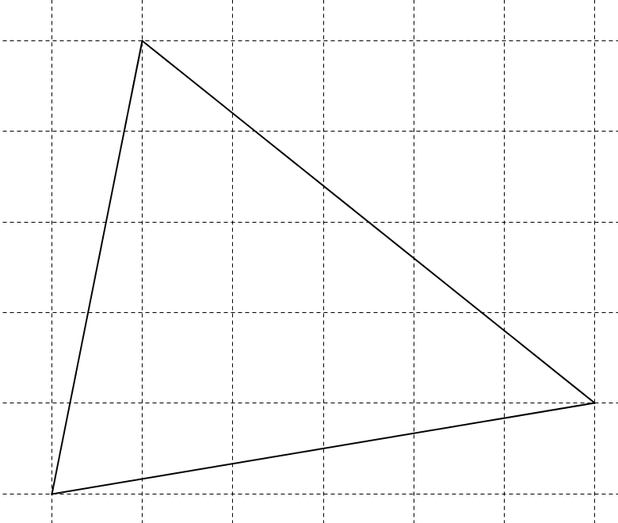
Tip if you do not have any idea how to start with this question.
Suppose you want to make a triangle of exact area 14,5 cm². Using the formula of the nails, you can try to create a triangle with only three points on the border; this will be the three vertices of your triangle. All you have to do now, is to make sure there lie exactly 14 nails inside your triangle. Can you see why?
A little experimenting on your nail board can lead to the triangle below, which has an area of exactly 14,5 cm².

d) Using the formula of the nails, you can detect new statements. Try to complete the following statement. “Every triangle on a nail board with an area of 1,5 cm² …………
…………………………………………………………………………………………”
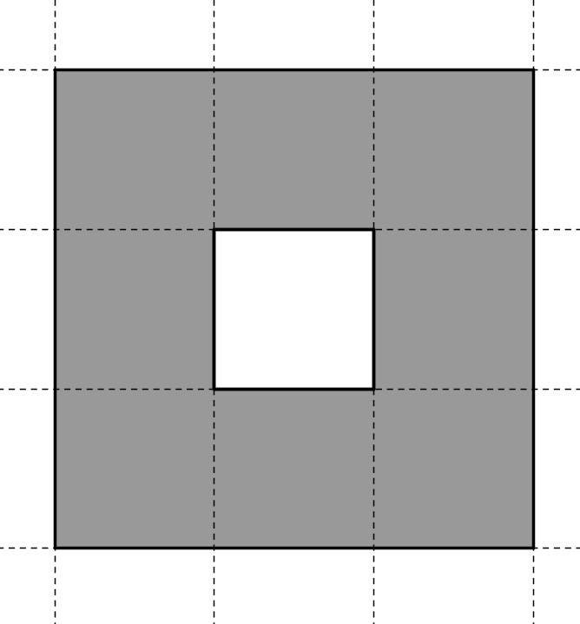
e) Calculate the real area of the grey figure (with a hole inside) by counting unit squares. What should be the area according to the conclusion on page 4. What do you notice?
……………………………………………………………………

……………………………………………………………………
Each member of the group creates another figure with one hole (you’ll need two elastic bands). Make sure the two elastic bands are non-intersecting and be creative! Try to formulate an alternative for the formula on page 4 for figures with one hole in it by comparing area and counting nails.
f) Challenge. Try to make a figure on the nail board with one elastic band and where the conclusion on page 4 does not hold.

